Walkthrough 31 Routing and Navigation

https://sapui5.hana.ondemand.com/#/topic/e5200ee755f344c8aef8efcbab3308fb



Core Changed Codes Compared to Walkthrough 25 Version:

1 Overview.view.xml 复制App.view.xml变更文件名称为Overview.view.xml

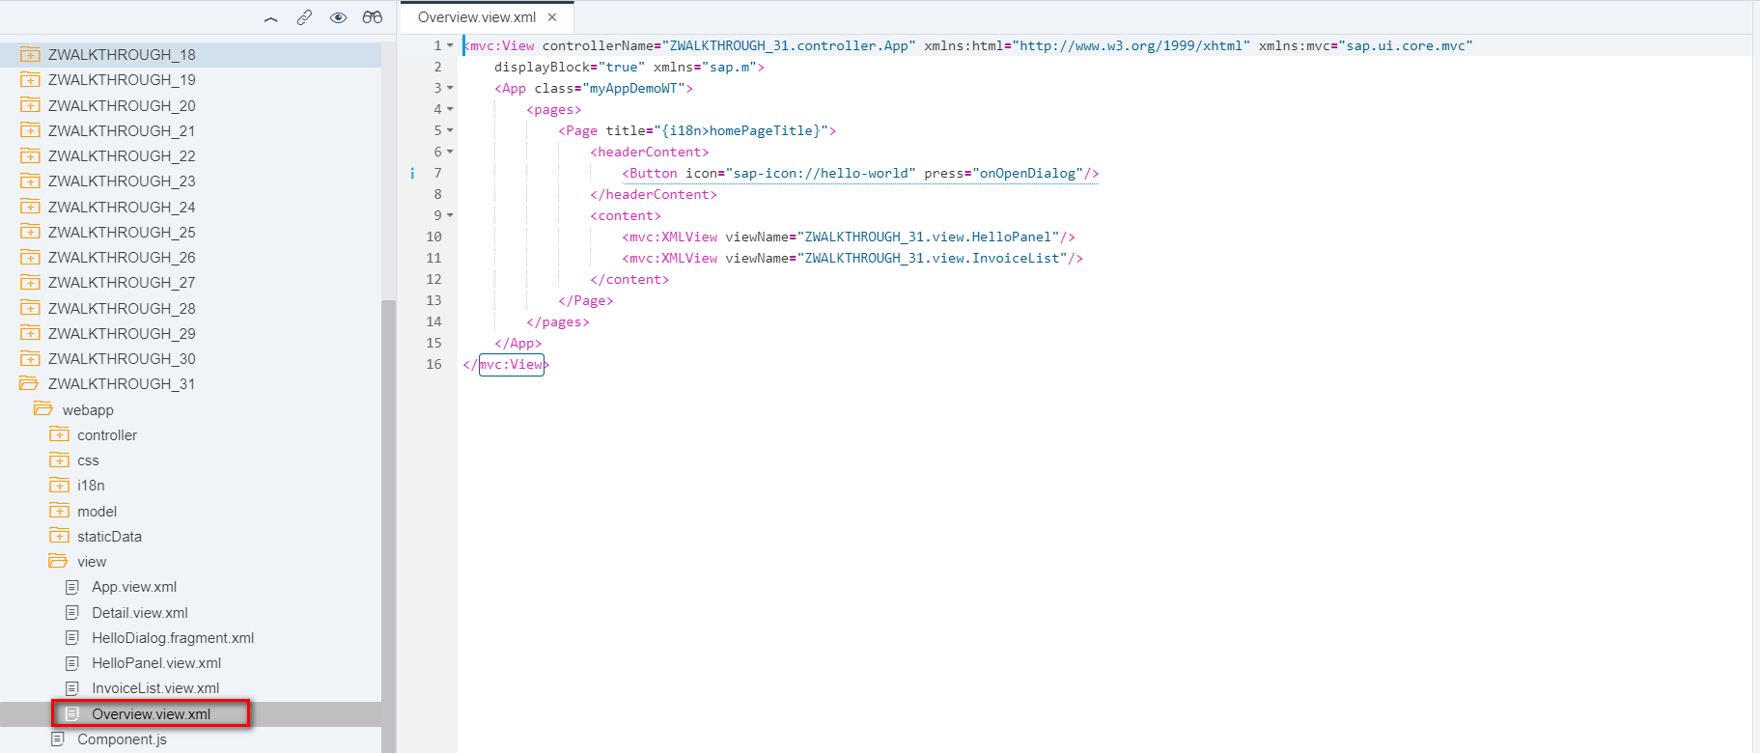

2 App.view.xml 仅包含Shell控件 App-id后续为配置在manifest文件中

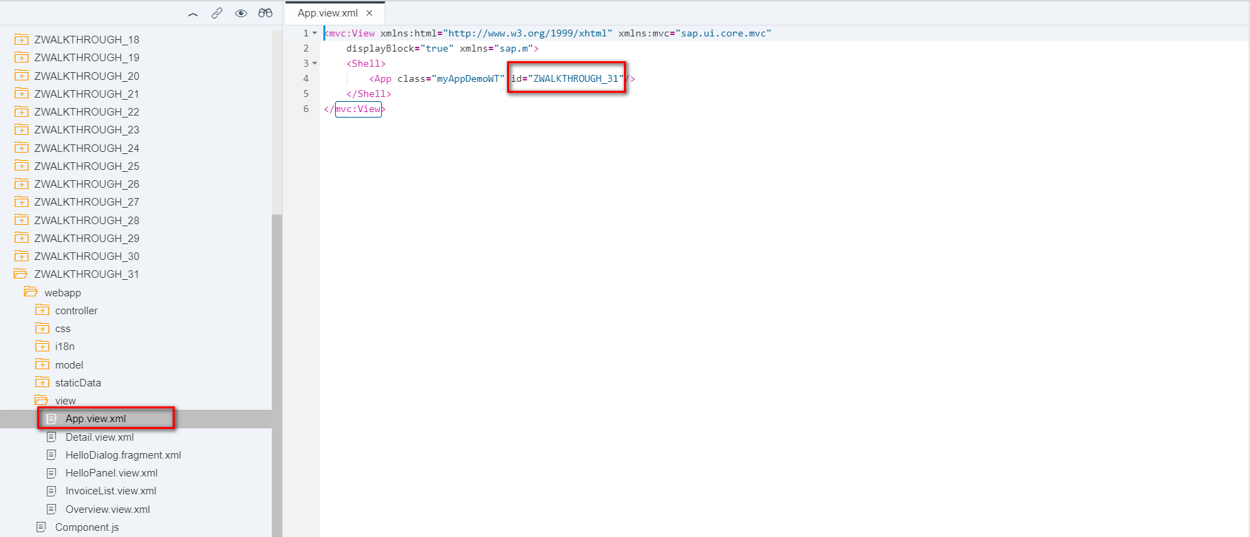

3 Detail.view.xml 新建明细界面

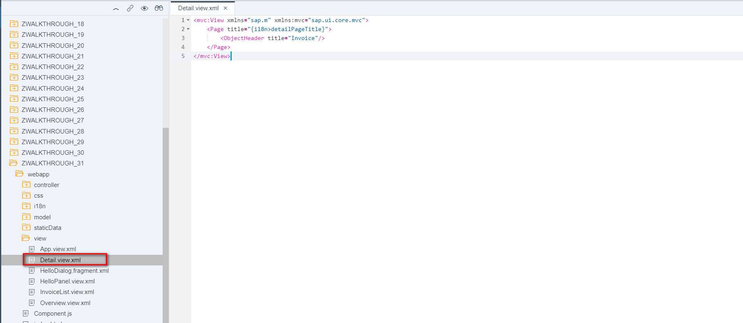

4 manifest.json 配置路由页面主数据

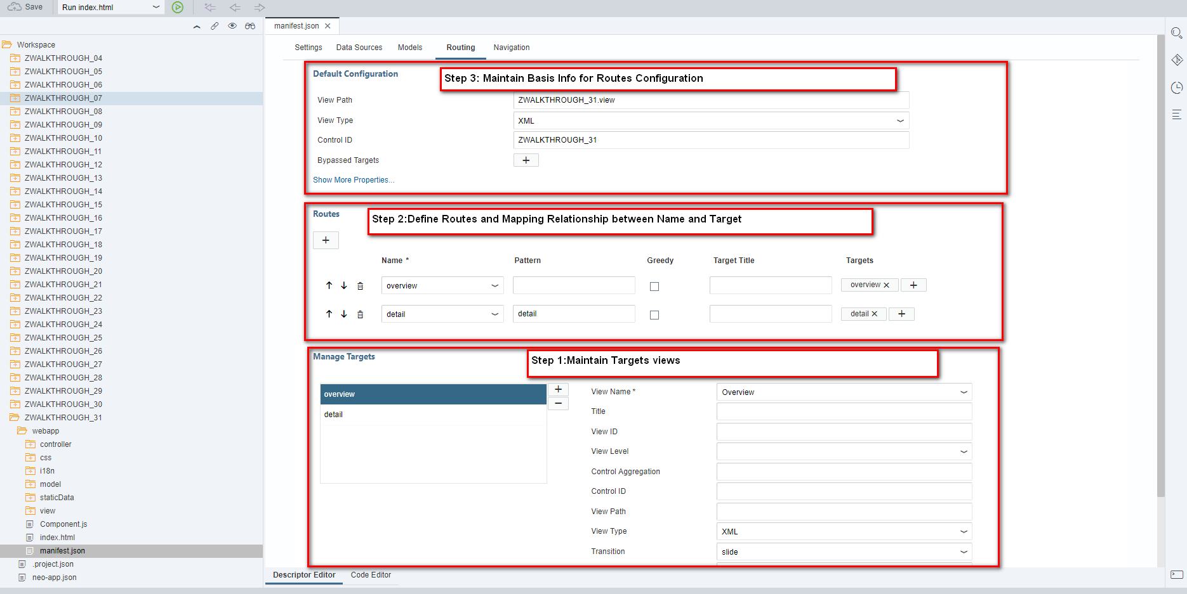

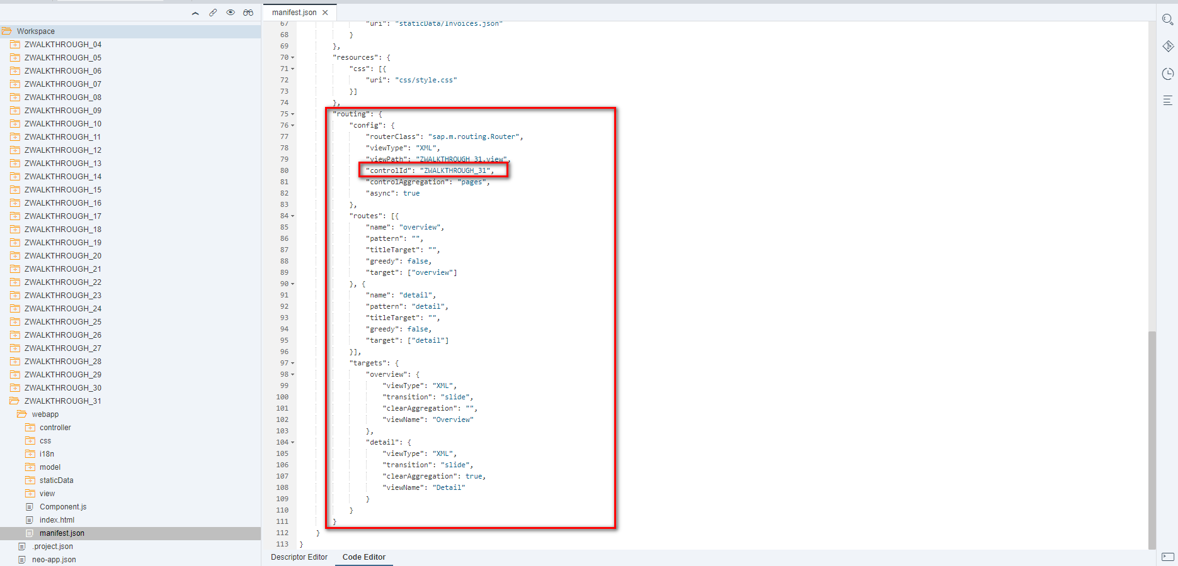

5 Component.js Router初始化并加载初始视图

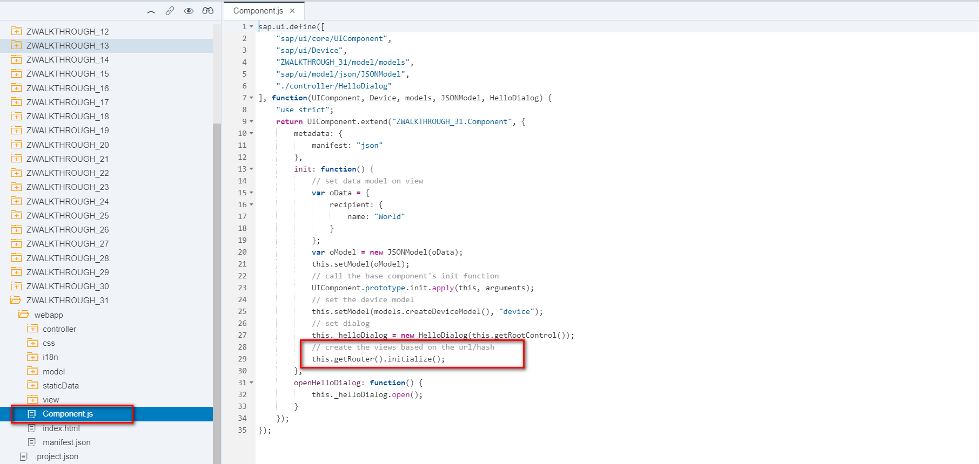

6 InvoiceList.view.xml 为列表行项目增加导航行为

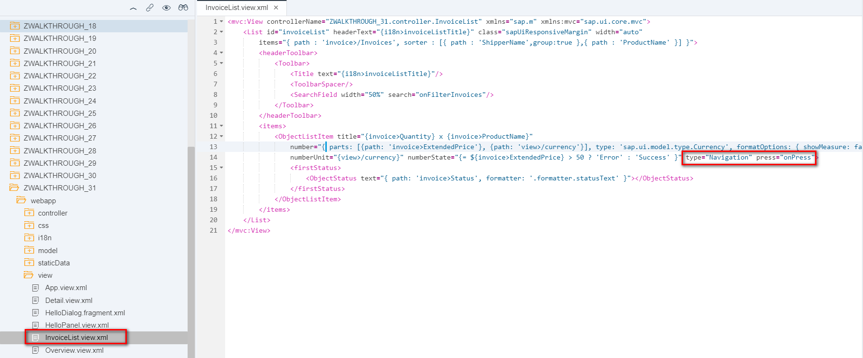

7 InvoiceList.controller.js 为列表行项目导航行为实现页面导航

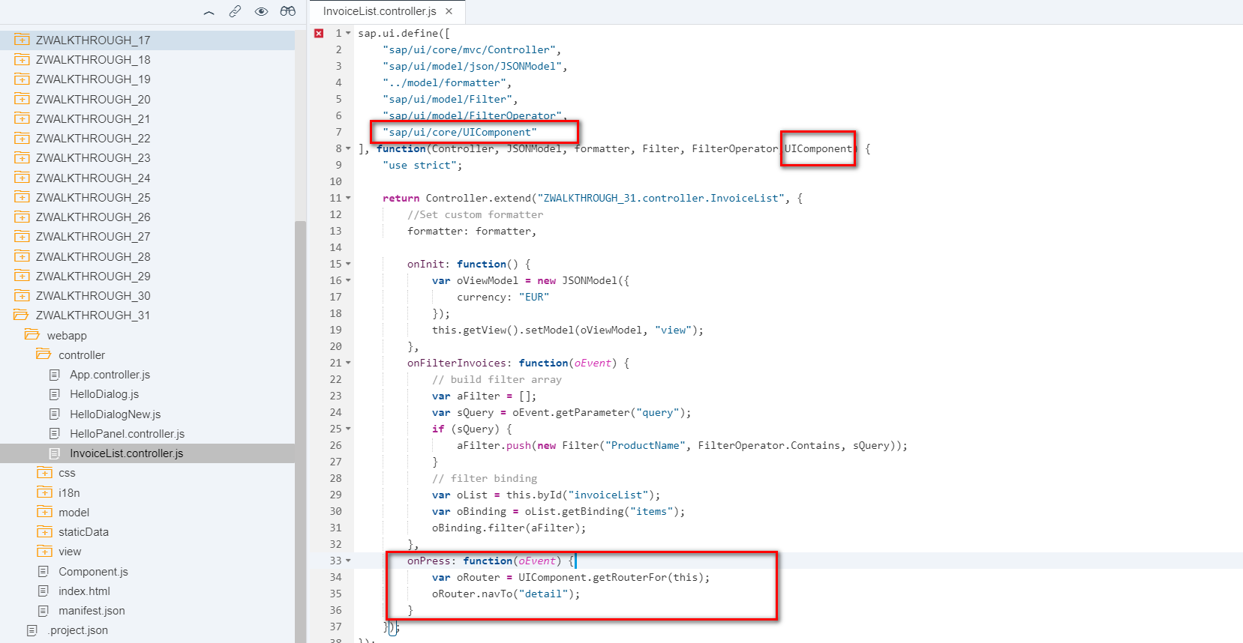

i18n 文本对象管理

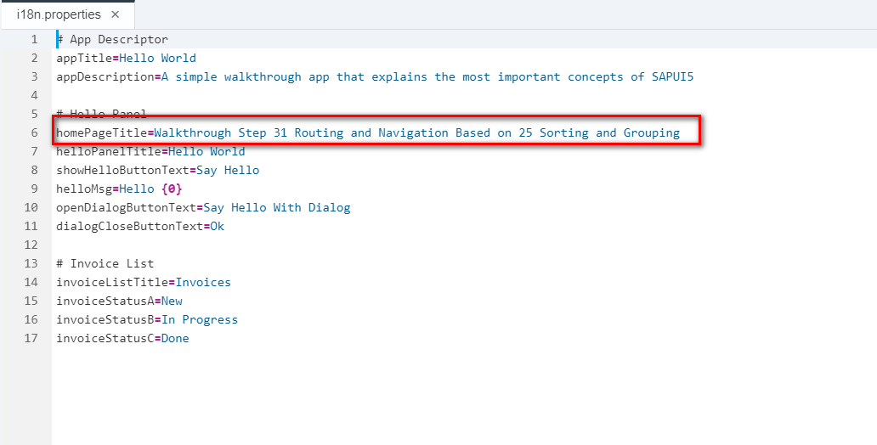

Result

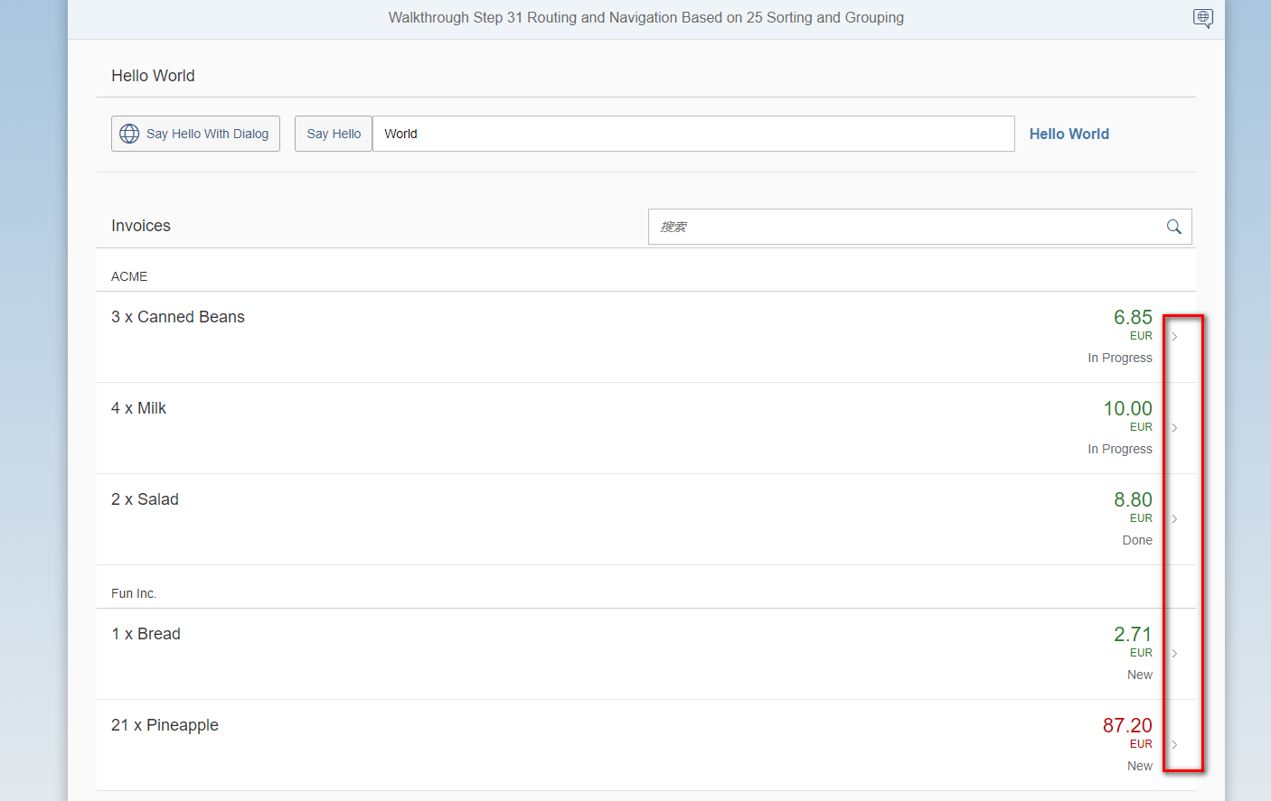

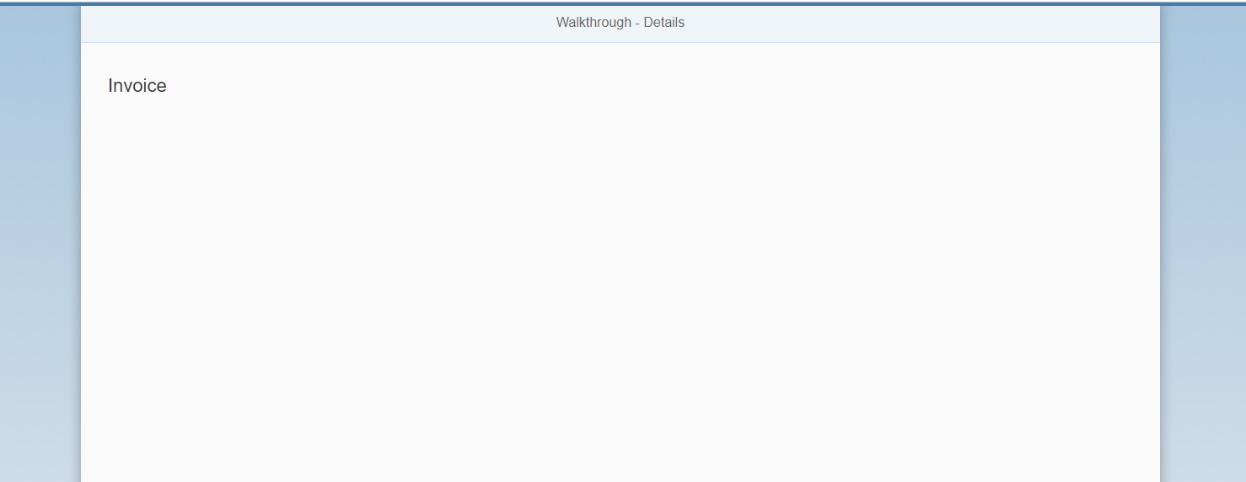

Git:

https://github.com/xiexiaop/SAPUI5-2-Round/tree/master/Projects/ZWALKTHROUGH_31

2019/02/07 XiaoMi Beijing Zac,Xie